Alumni Activity
Entrepreneurs’ Nexus 2K26 – Alumni Entrepreneur
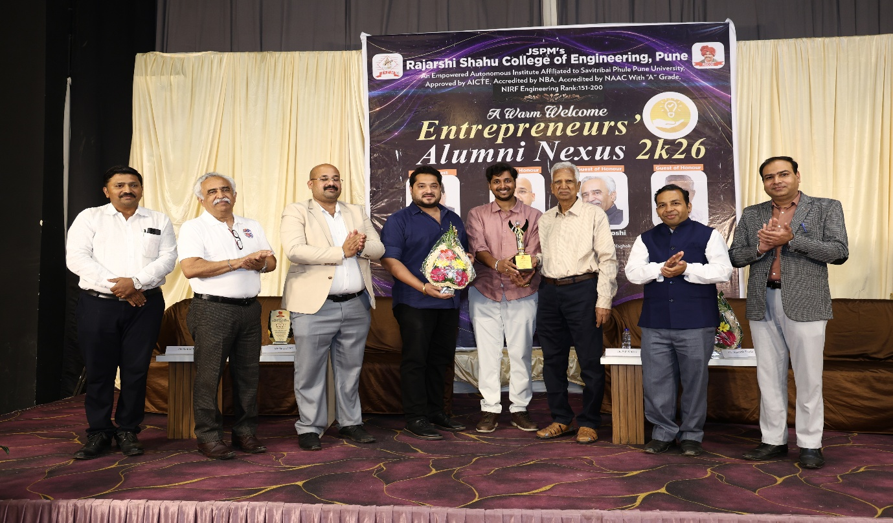
Entrepreneur Alumni Awardee – Mr. Akash Dalvi – Founder, Bricklane (Batch 2024, Civil )
As above
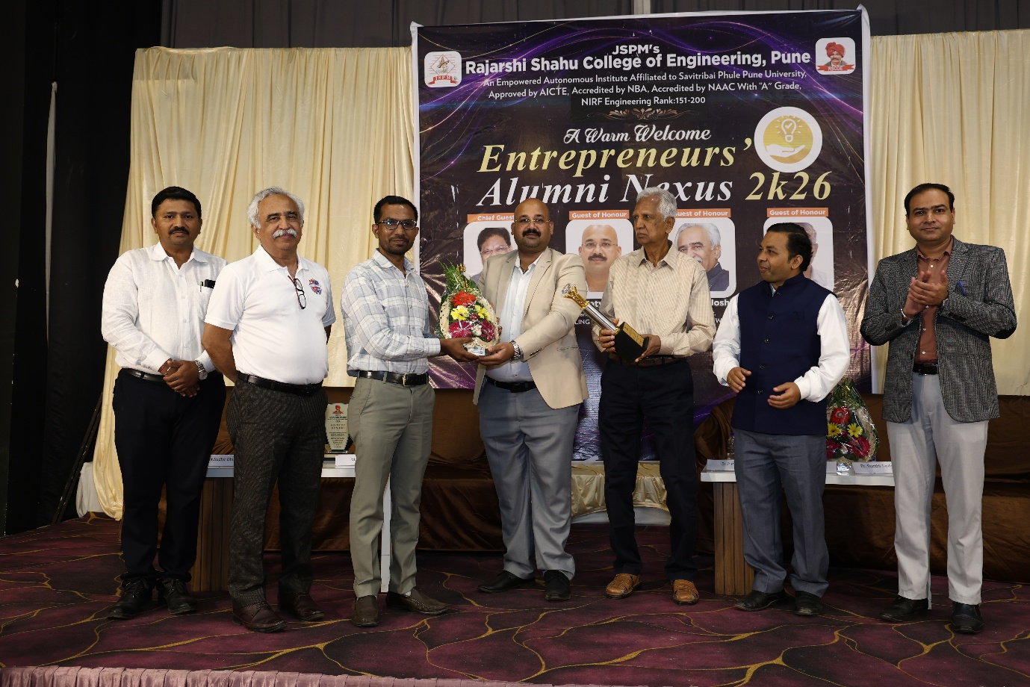
Entrepreneur Alumni Awardee - Dnyaneshwar Hadke – UWS Enviro(Batch 2011, Mech) as above.

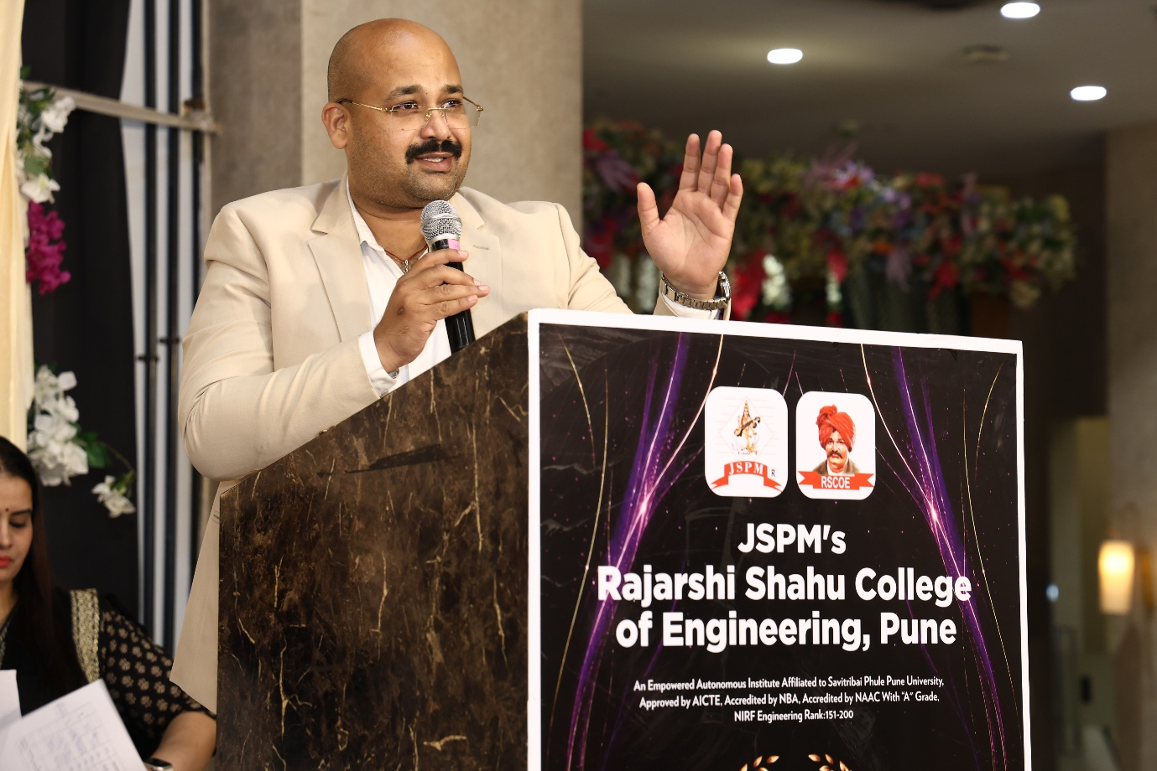
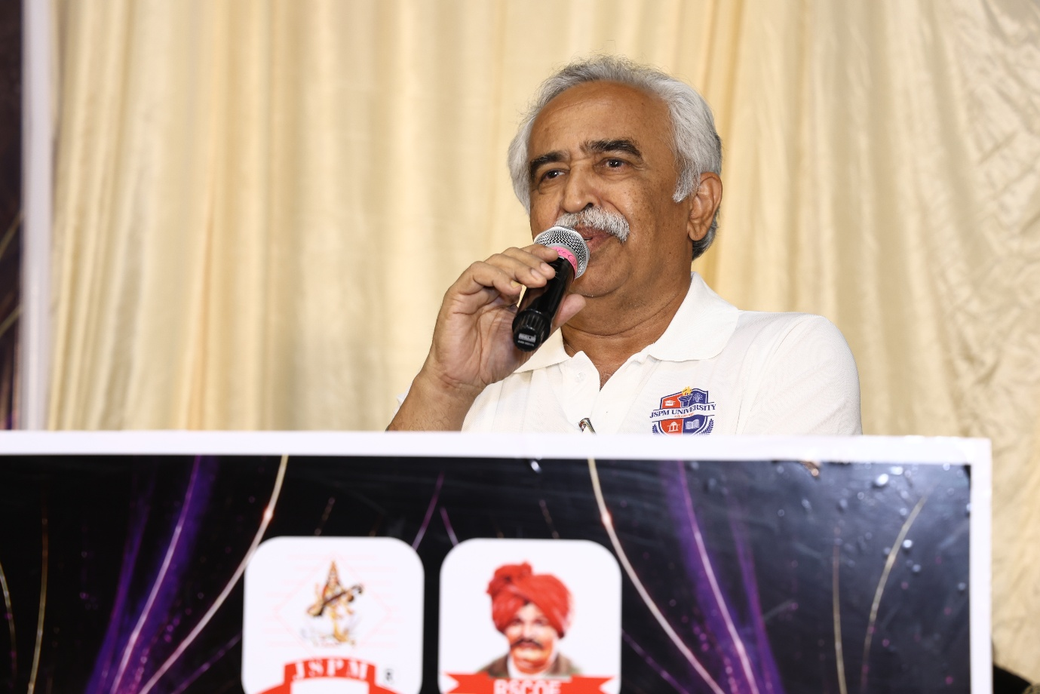
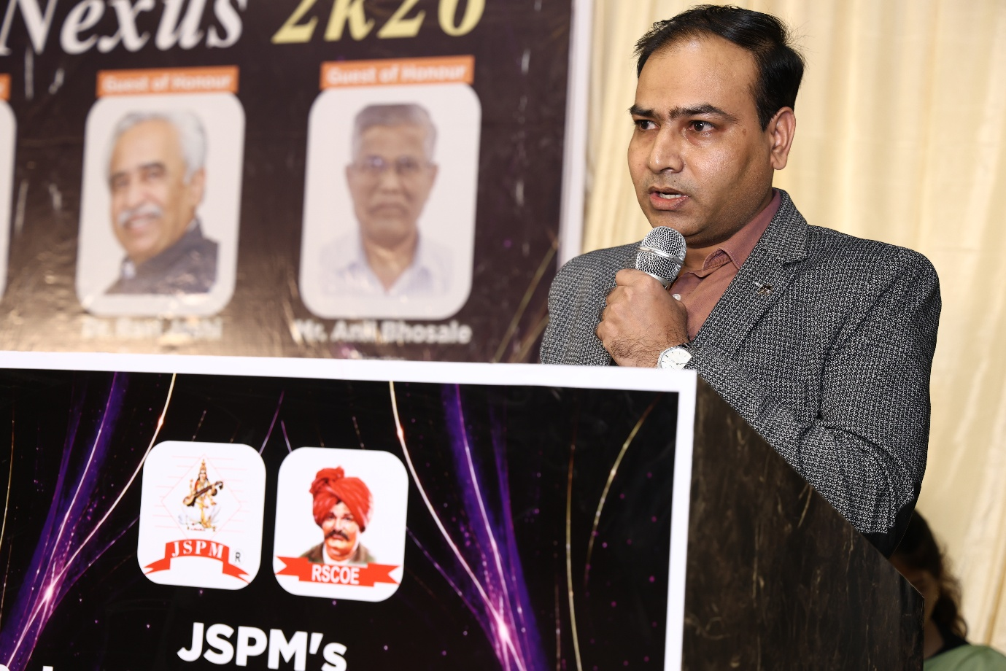
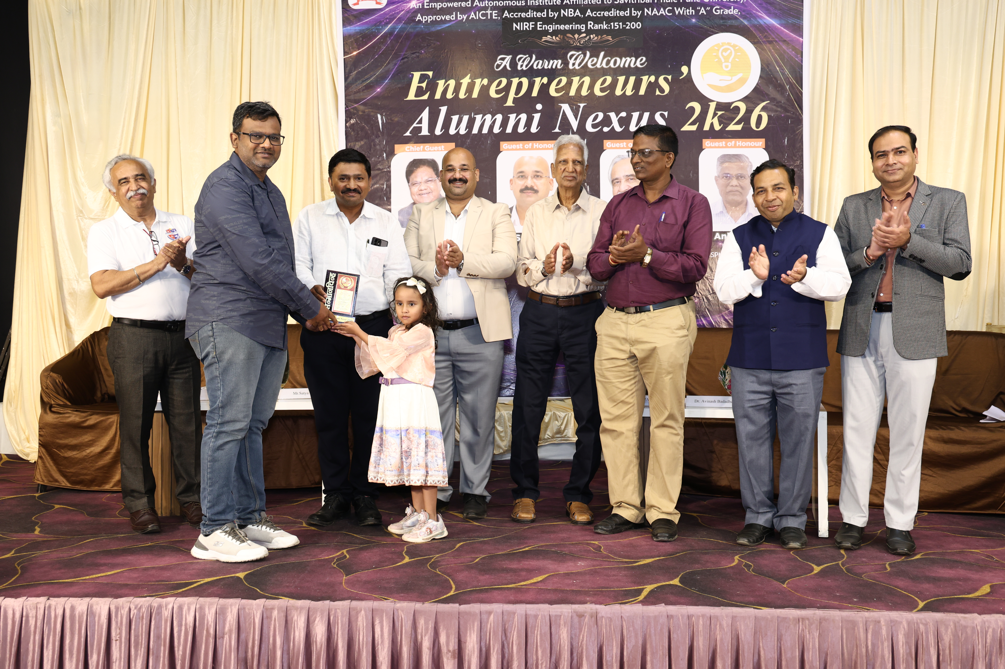-
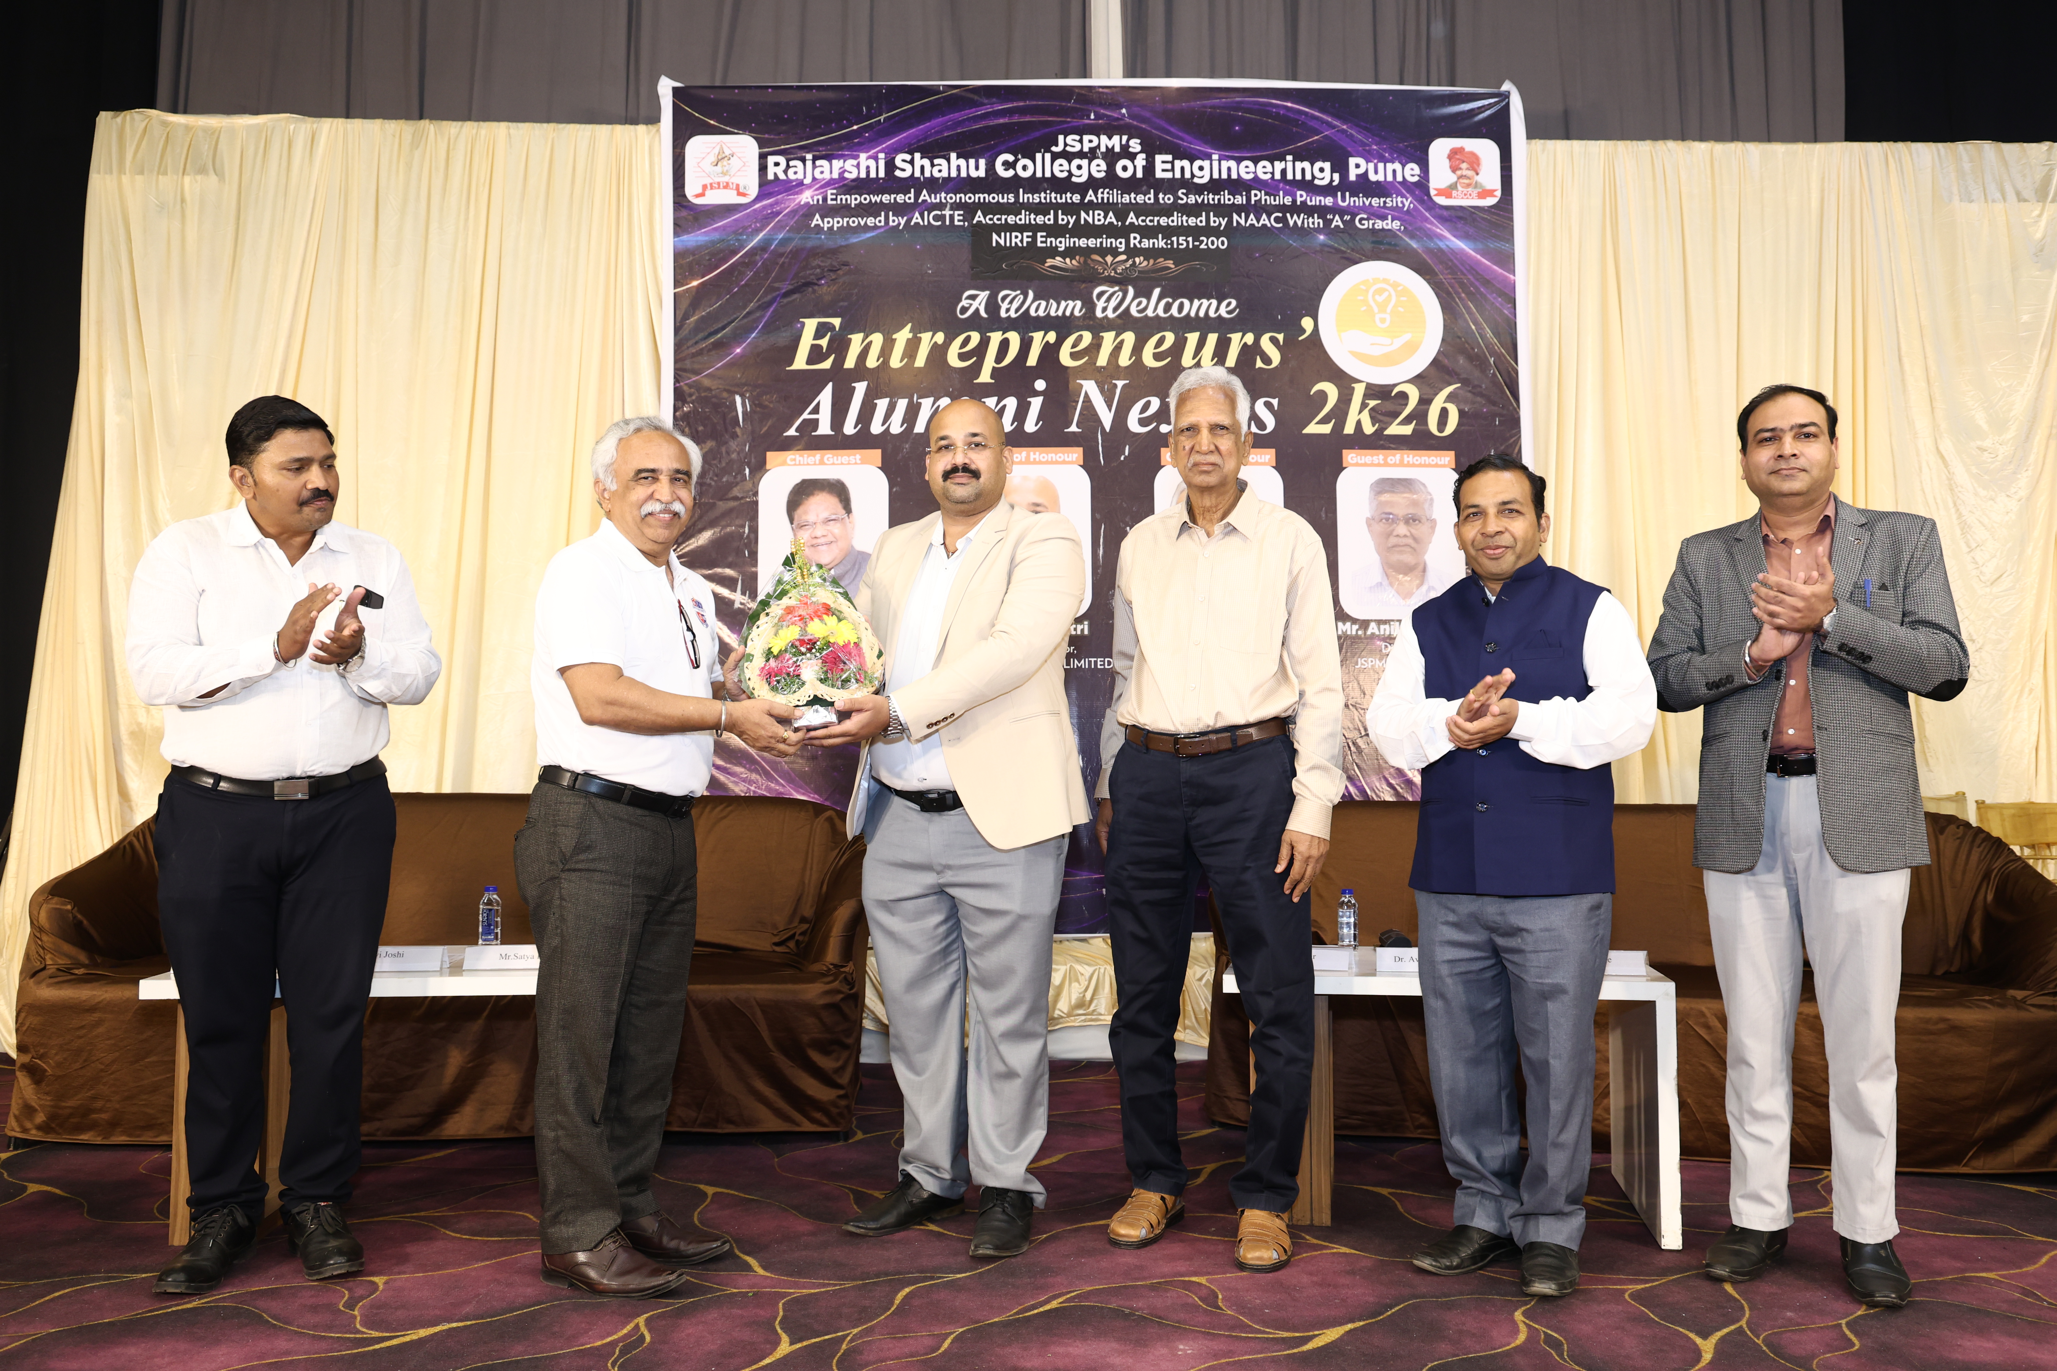

___________________________________________________________________________
RSCOE Alumni Meet – Milaap 2025
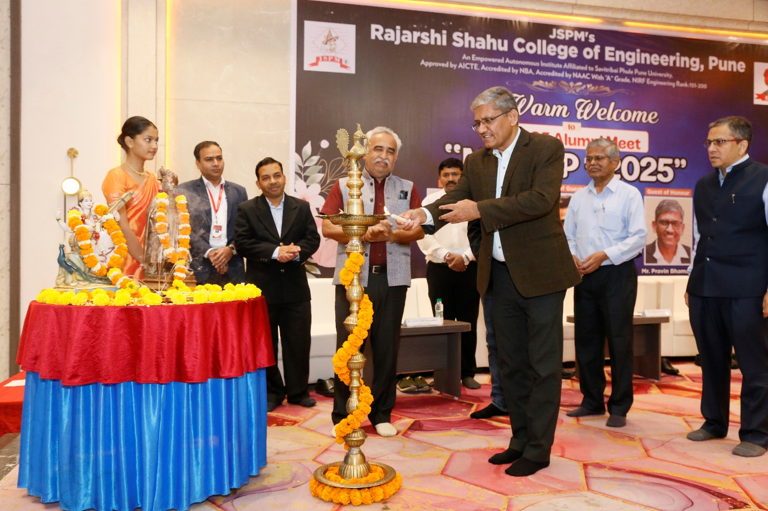
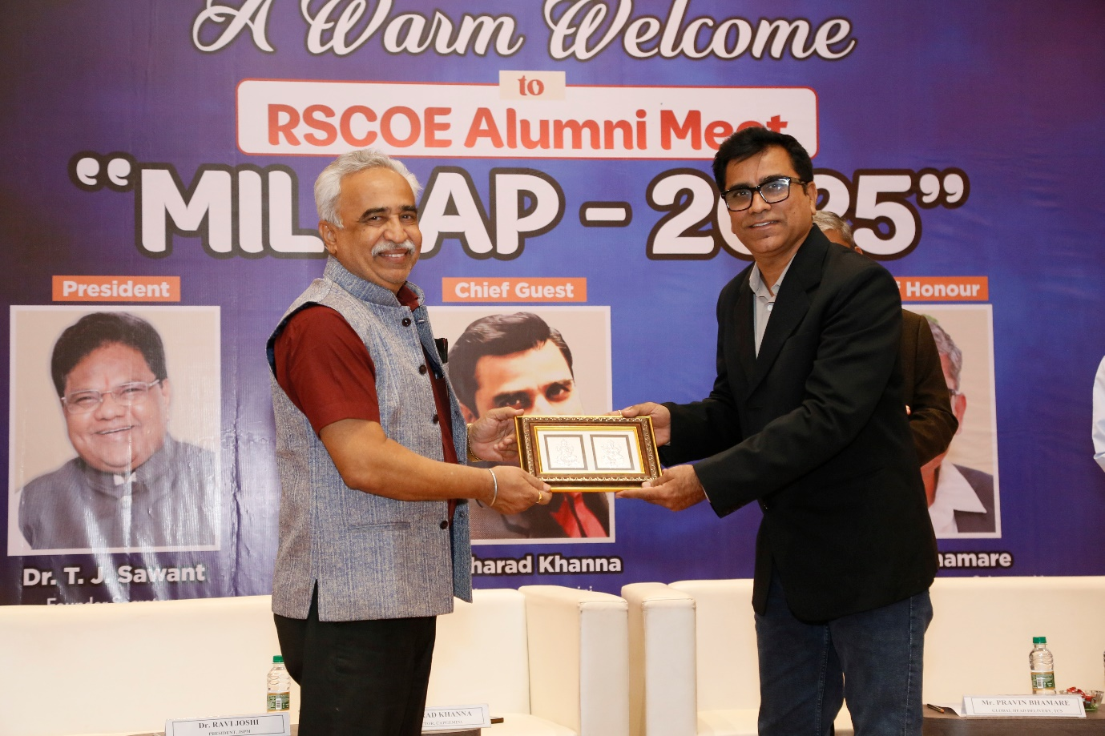

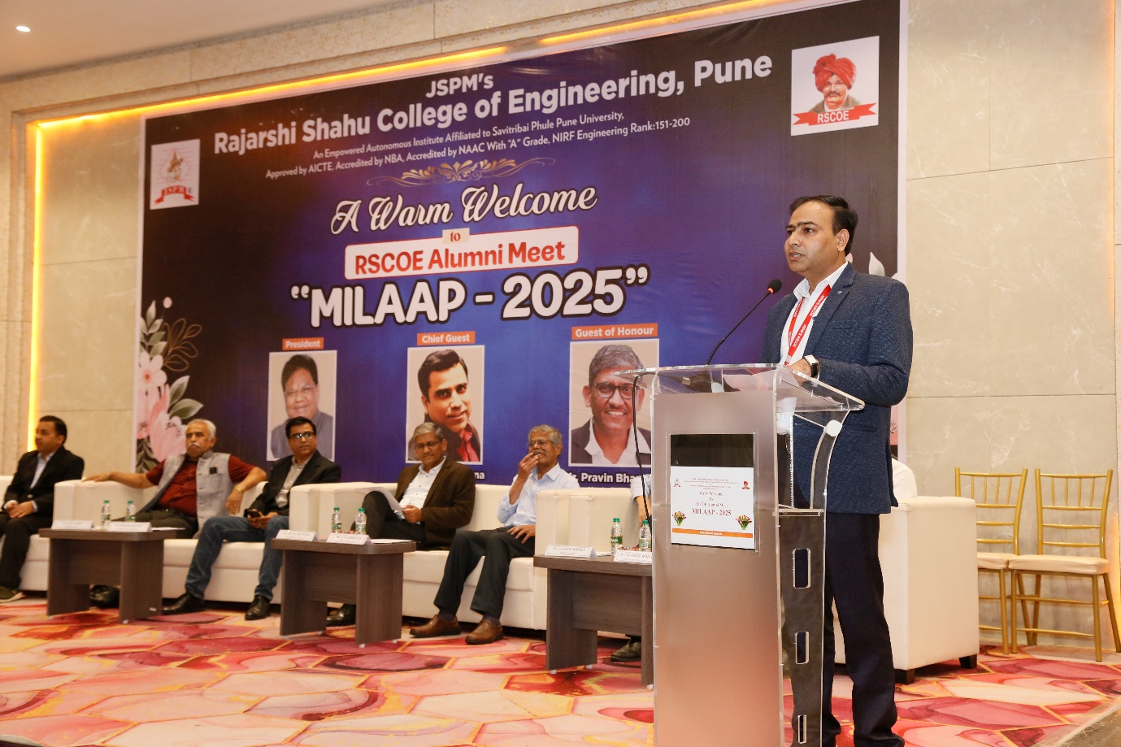
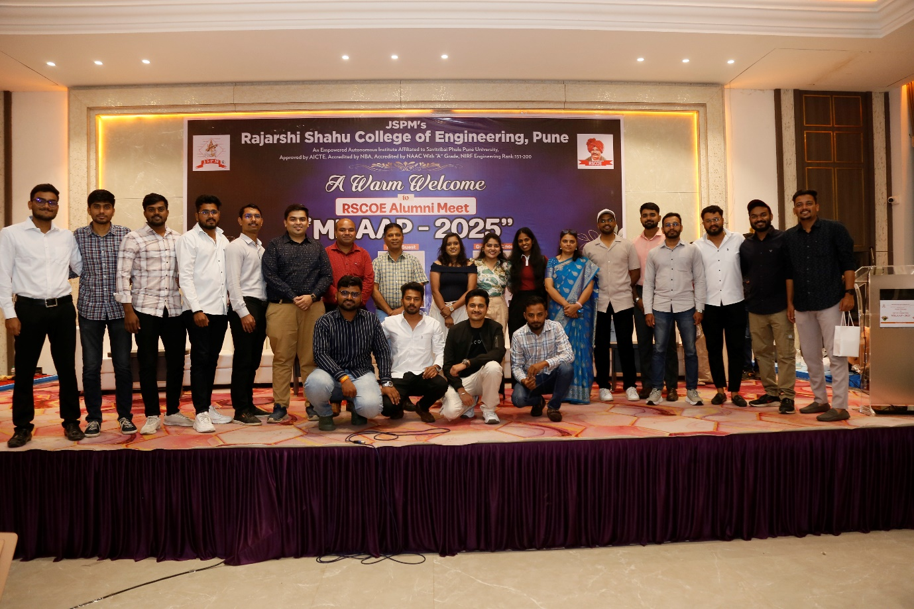
___________________________________________________________________________
Coffee with Alums” – Lets Connect….Alumni Meet 2026 Dated 27th Feb 2026
